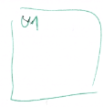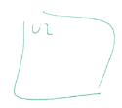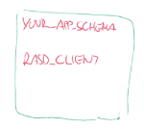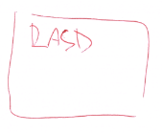

grant execute on   
»your_app_schema«.  
RASD_CLIENT to U1

grant execute on   
»your_app_schema«.  
RASD_CLIENT to U2

grant execute on   
»your_app_schema«.  
RASD_CLIENT to Un

User U1 generated  
programs

User U2 generated  
programs

User Un generated  
programs

[http://URL:port/your_application_url/  
welcome.page](http://URL:port/your_application_url/welcome.page)

Login to RASD with U1

[http://URL:port/your_application_url/  
welcome.page](http://URL:port/your_application_url/%0bwelcome.page)

Login to RASD with U2

[http://URL:port/your_application_url/  
welcome.page](http://URL:port/your_application_url/%0bwelcome.page)

Login to RASD with Un

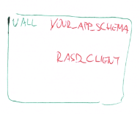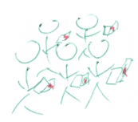

[http://URL:port/your_application_url/  
welcome.page](http://URL:port/your_application_url/%0bwelcome.page)

